DriverPass System Design Document
Johan Tovar | CS 255 | Project Two
Design scope: a blended process-and-object model for student enrollment, two-hour driving lessons, online practice tests, staff records, reporting, account access, and DMV updates.

UML Diagrams

UML Use Case Diagram
The Project One use case diagram is retained below in its three original views. The images cover registration and reservations; learning and lesson records; and administration, reporting, and DMV updates.
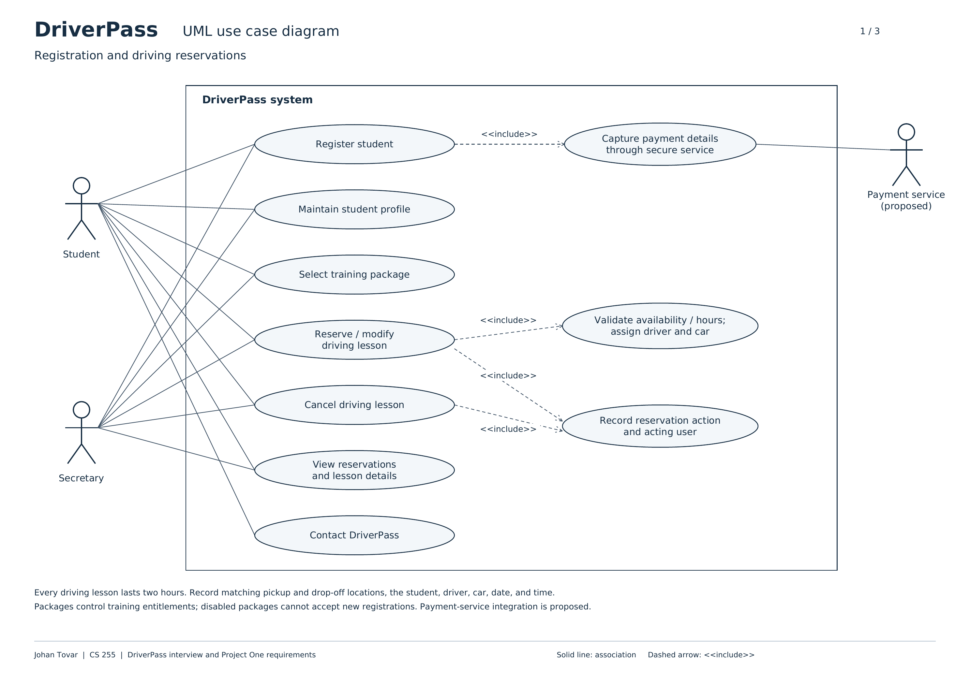
Figure 1. Registration and driving reservations (prior Module Six diagram).

UML Use Case Diagram — Learning and Lesson Records
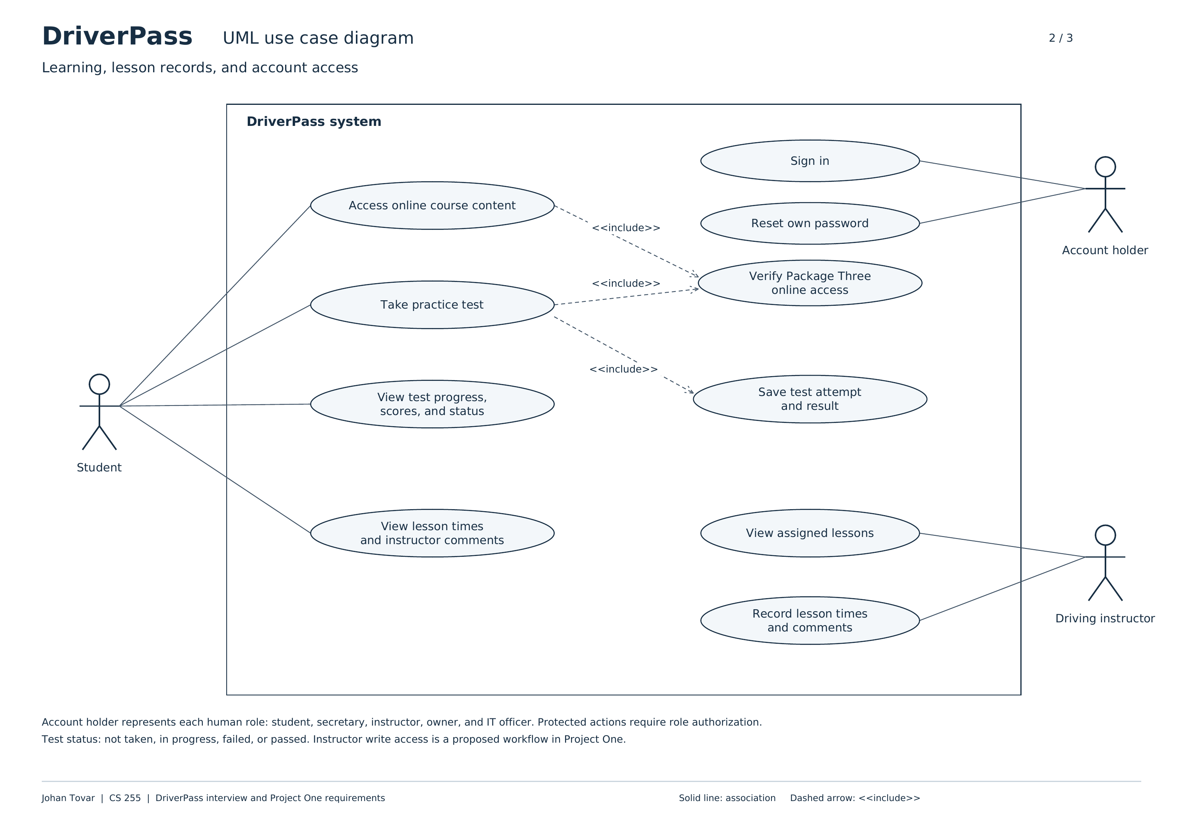
Figure 2. Account access, course content, practice tests, progress, and driver comments.

UML Use Case Diagram — Administration and DMV Updates
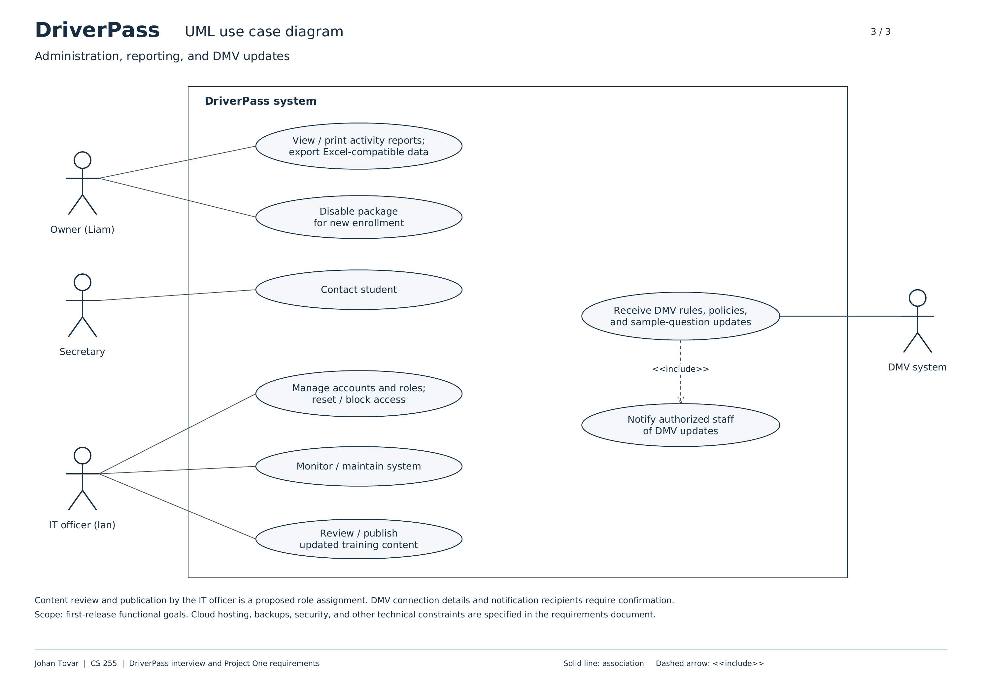
Figure 3. Owner, secretary, IT officer, and DMV interactions.

UML Activity Diagrams
The two selected use cases are Reserve a Driving Lesson (FR05, FR07, FR09–FR13) and Take a Practice Test (FR15–FR16).
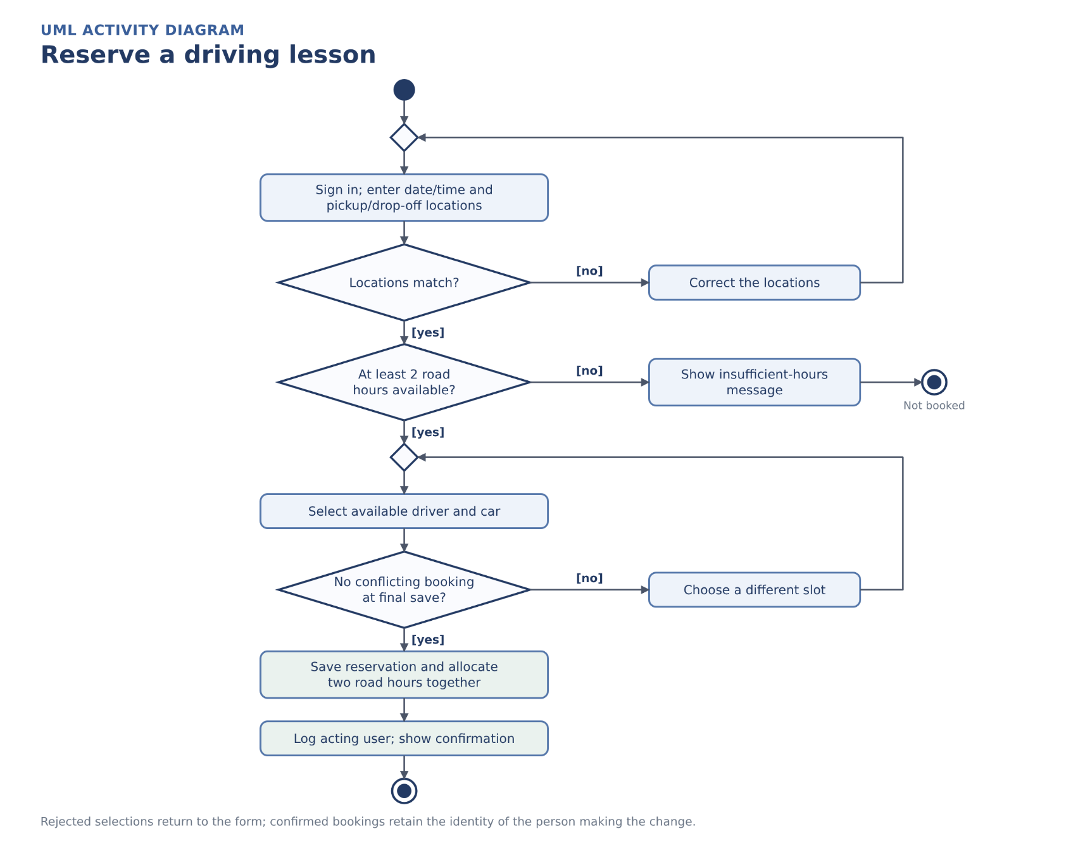
Figure 4. Booking a two-hour road session, with location, entitlement, resource, and audit checks.
A successful booking records the student, assigned driver, car, matching locations, two-hour slot, package allocation, and the actual signed-in user. Rejected slots do not create reservations.

UML Activity Diagram — Take a Practice Test
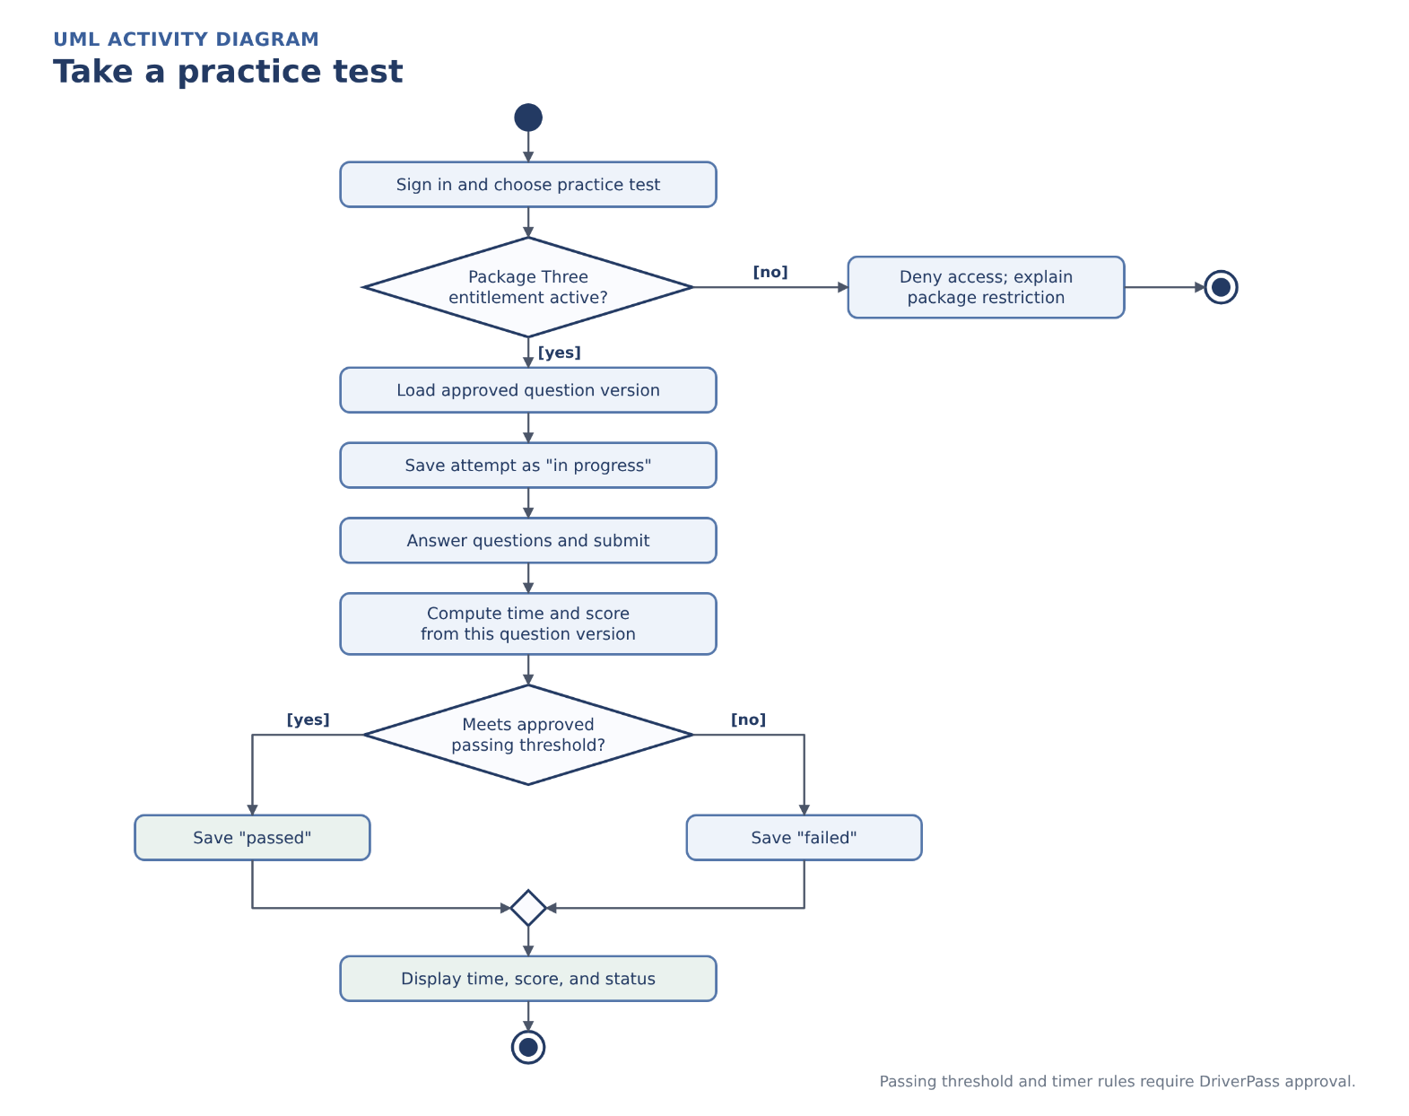
Figure 5. Package Three access, test progress, scoring, and saved results.
Scores use the approved question version and a client-approved passing threshold. The design distinguishes an in-progress attempt from a completed pass or fail.

UML Sequence Diagram
The sequence below expands the same Reserve a Driving Lesson use case as Figure 4. The browser, booking service, enrollment data, reservation store, and audit data exchange information in time order.
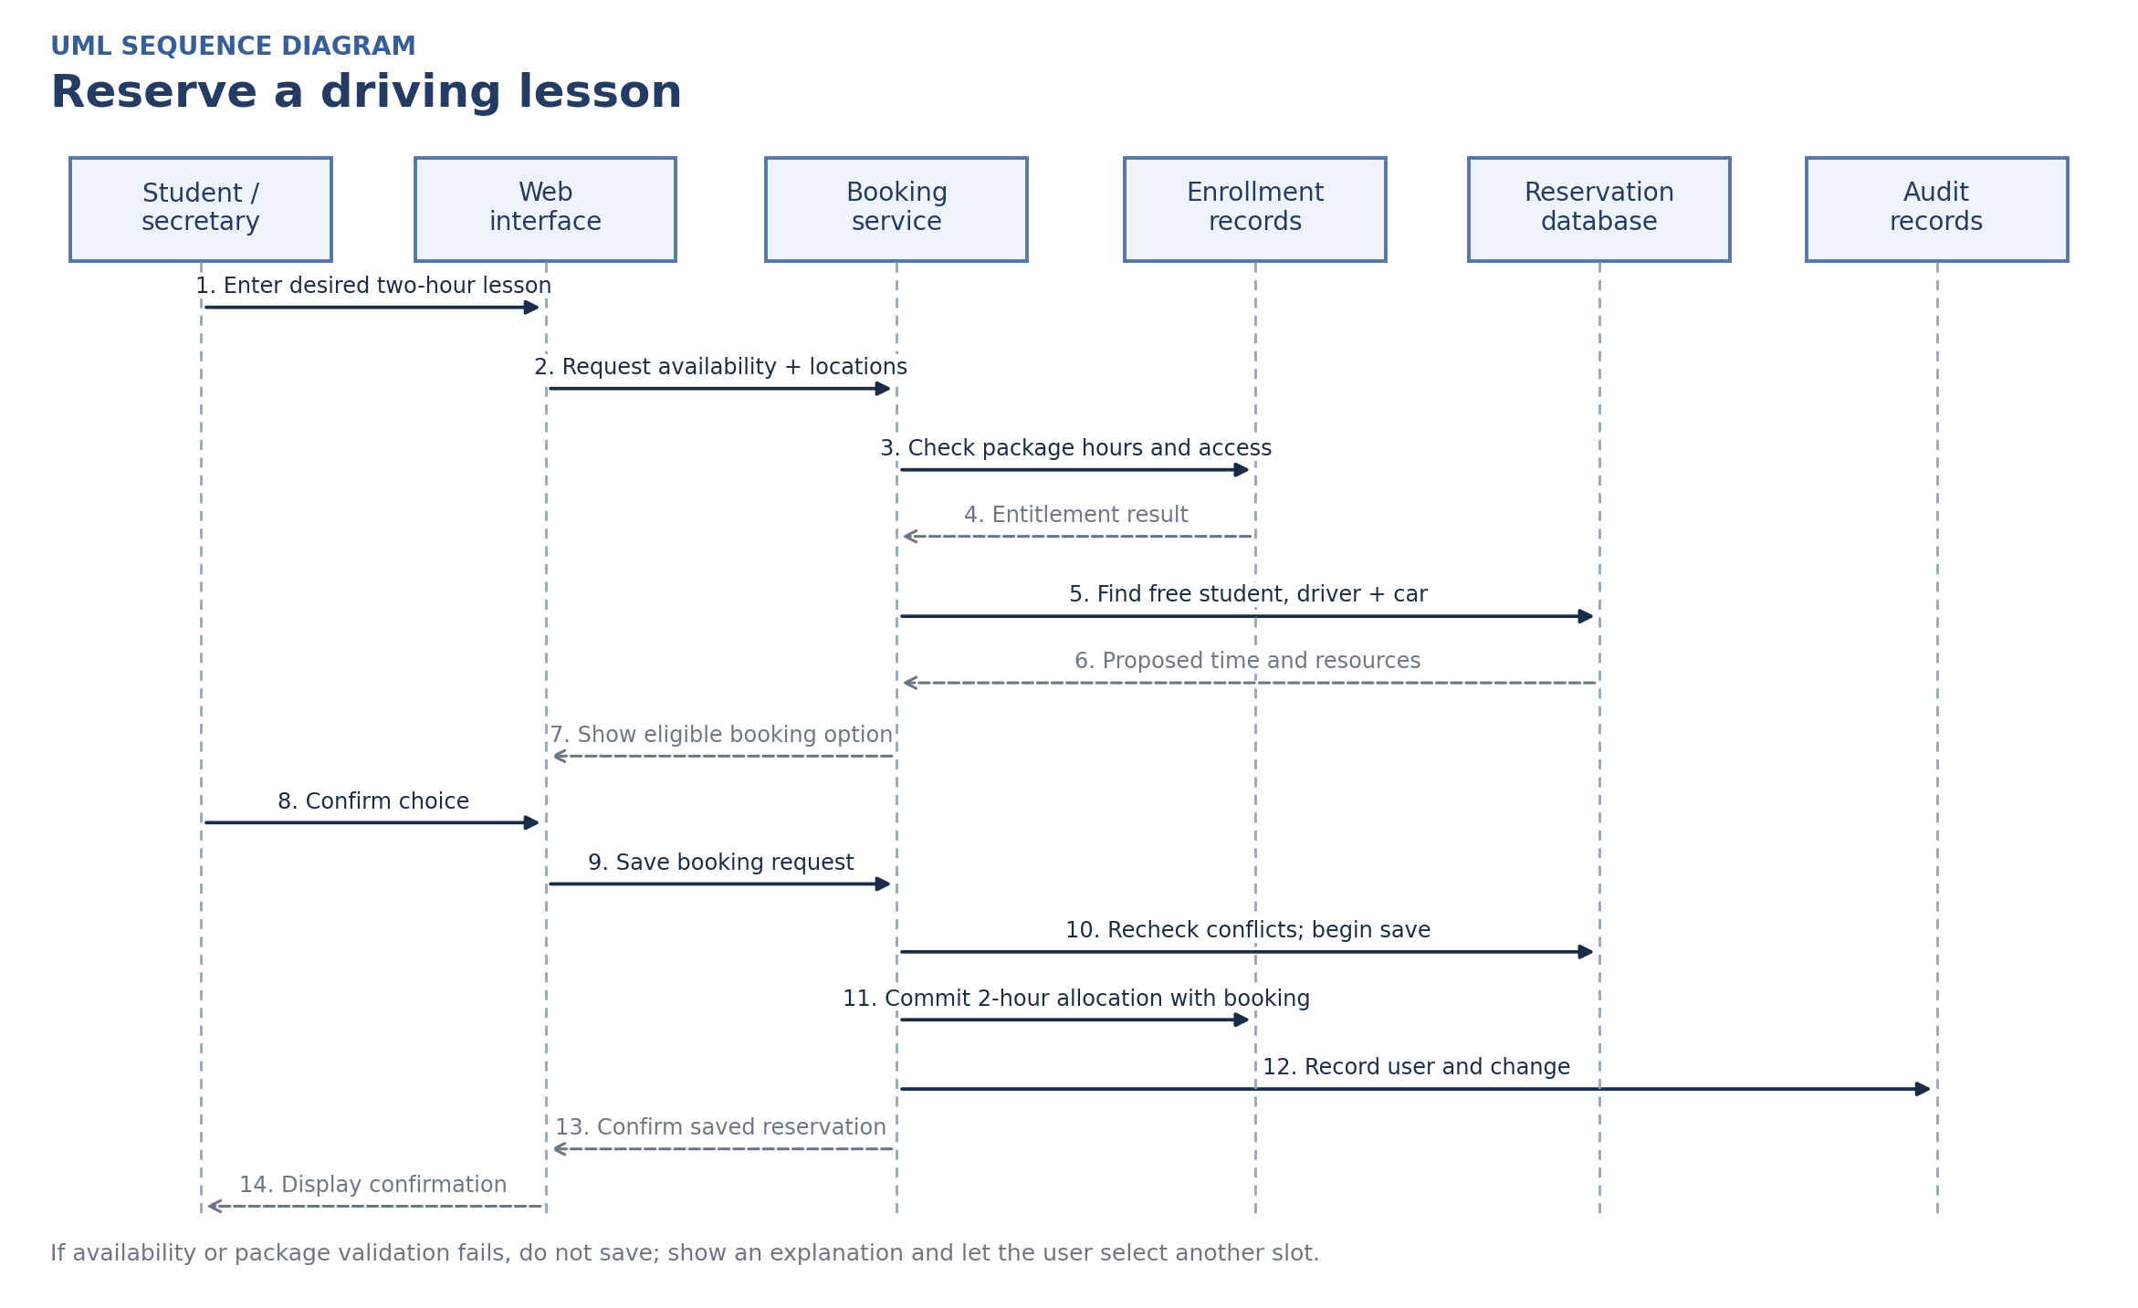
Figure 6. Booking messages, final availability checks, package-hour allocation, and confirmation.
The final conflict check, reservation insert, and entitlement allocation must run within one database transaction. Audit attribution is recorded as part of the completed booking operation.

UML Class Diagram
Major classes, attributes, and relationships are shown below. Each relationship line identifies the associated number of records; 0..* means zero or more.
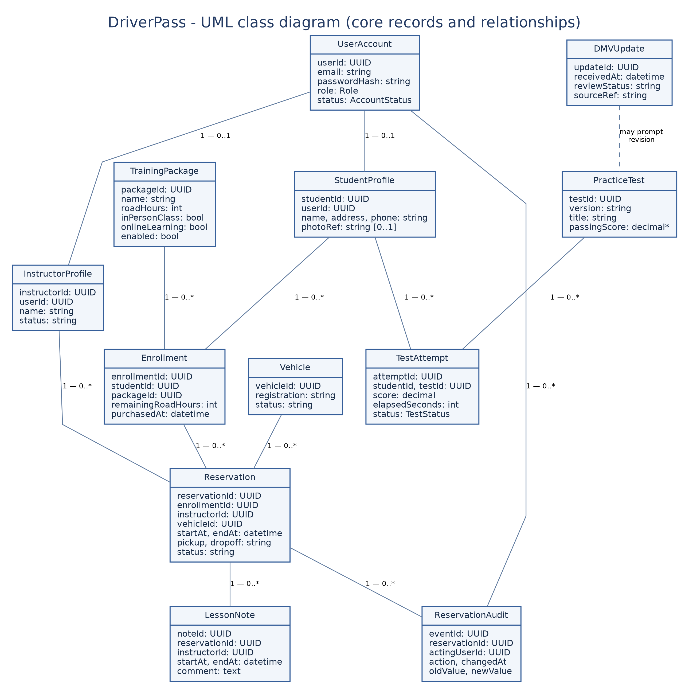
Figure 7. DriverPass core classes and their associations. *The passing score remains subject to approval.
The class model uses stable identifiers and separates active account access from historical records. Package, enrollment, reservation, test attempt, and audit data remain independently traceable.

Technical Requirements
The items below translate the documented Project One scope into a proposed implementation design. Vendor choices, thresholds, and unresolved operating rules are identified rather than treated as confirmed client commitments.
Category | Implementation requirement
Hardware and user devices | Students, staff, Liam, and Ian need an internet-connected computer, tablet, or smartphone. Office computers can use standard printers for reports. No equipment is installed in the 10 training cars.
Web software and compatibility | A responsive web application with clear forms and confirmation messages, supported on current browsers for Windows, macOS, iOS, and Android. No app installation is required.
Server-side application modules | Separate modules for accounts and roles, student profiles, packages, reservations, lesson notes, online tests, reports, and DMV updates, so one module can change without rewriting the others.
Database and consistency | A managed relational database for accounts, enrollments, vehicles, reservations, test attempts, and change history. Booking checks run in a single transaction to prevent double-booking a student, driver, or car.
Package and access rules | Package One: 6 road hours (3 sessions). Package Two: 8 road hours (4 sessions) plus an in-person DMV lesson. Package Three: 12 road hours (6 sessions), the in-person lesson, and online tests. Disabled packages accept no new students.
Authentication and authorization | Secure sign-in with hashed passwords and expiring reset links. Role-based access: customers see their own data, instructors see their lessons, the secretary books for customers, Liam sees reports, and Ian manages accounts.
Sensitive data and payments | HTTPS for all traffic and encryption for sensitive stored data. Card payments go through an approved payment provider; DriverPass keeps only a reference, never full card details.
Cloud infrastructure and recovery | Cloud hosting with a managed database, file storage, separate test and production environments, monitoring, and scheduled backups with restore tests. The cloud vendor is chosen during implementation.
DMV and external services | An adapter receives DMV rule and practice-question updates, notifies staff, and requires review before publishing. DMV access details still need confirmation.
Testing, tools, and reports | Lucidchart for UML, source control, automated, cross-browser, and security testing. Printable reports and Excel-compatible downloads that do not change system records.

Proposed performance and release checks
Project One proposed, but the client has not approved, these benchmarks: 95% of ordinary page requests within 3 seconds and reservation saves within 5 seconds at an agreed normal workload, excluding third-party delay. A save must never display success if it fails. Confirm device/browser coverage and network/load assumptions before testing.

Open implementation decisions
DriverPass must approve hosting/service levels, staff permissions, payment provider and charging/refund behavior, cancellation and no-show rules, release of reserved hours after cancellation, practice-test pass marks and time limits, backups and retention/recovery targets, DMV data access and notification timing, photo/special-needs access, and in-person class capacity. No unapproved value is embedded as a hard-coded policy.

Source alignment
This document builds on the Project One business requirements (FR01–FR21), the DriverPass interview materials referenced there, and the original Module Six use case diagram. New implementation detail is a proposed design, not a statement that DriverPass already approved it.

